Chester Alba SUMMITT

1887–1970

Birth 04 MAR 1887 • Dyersburg, Dyer County, Tennessee

Death 10 MAR 1970 • Memphis, Shelby County, Tennessee

Summary

When Chester Alba SUMMITT was born on March 4, 1887, in Dyersburg, Tennessee, his father, James, was 46 and his mother, Lucy, was 32. He was married three times and had five sons and four daughters. He died on March 10, 1970, in Memphis, Tennessee, at the age of 83, and was buried in Cardwell, Missouri.

Chester Alba SUMMITT

Spouses

Katie Okalona DARDEN

Parents

James Lee SUMMITT

Lucy Frances WHITE

Birth: 04 Mar 1887 &bull; Dyersburg, Dyer County, Tennessee; Residence: 1900 &bull; Civil District 3, Dyer, Tennessee, Age: 13; Marital Status: Single; Relation to Head of House: Son; Marriage: 29 Feb 1908 &bull; Cardwell, Dunklin, Missouri, United States; Residence: 1910 &bull; Buffalo, Dunklin, Missouri; Residence: 1920 &bull; Cardwell, Dunklin, Missouri; Residence: 1930 &bull; Buffalo, Dunklin, Missouri; Residence: 1 Apr 1940 &bull; Cardwell, Dunklin, Missouri, United States; Residence: 1940 &bull; Cardwell, Dunklin, Missouri, United States; Military: 1942 &bull; Cardwell (Dunklin) Missouri USA, WWII Draft Registration; Residence: 1950 &bull; Cardwell, Dunklin, Missouri, USA; Marriage: 5 Apr 1955 &bull; Cardwell, Dunklin, Missouri, United States; Marriage: 5 Apr 1955 &bull; Cardwell, Dunklin, Missouri; Death: 10 Mar 1970 &bull; Memphis, Shelby County, Tennessee, Age at Death: 83; Burial: Cardwell, Dunklin County, Missouri, USA; Residence: Dunklin, Missouri

4 Mar 1887 Birth

Chester Alba SUMMITT was born on March 4, 1887, in Dyersburg, Tennessee, to Lucy Frances WHITE, age 32, and James Lee SUMMITT, age 46.

04 Mar 1887 • Dyersburg, Dyer County, Tennessee

**What was Dyersburg, Tennessee, USA like when Chester Alba was born?**

Dyersburg, Tennessee, USA in 1887 was a bustling town with a rich history and a diverse population. Located in the southwestern part of the state, Dyersburg was a hub of economic activity and cultural exchange.

1. Economic Life:

Dyersburg thrived as a center for agriculture and trade. The fertile lands surrounding the town supported a thriving farming community, with cotton being the primary crop. The town boasted several cotton gins and warehouses, facilitating the processing and export of cotton to markets across the country. Additionally, the railroad, which arrived in Dyersburg in the 1870s, played a crucial role in connecting the town to larger cities and facilitating the transportation of goods.

1. Community and Culture:

The community in Dyersburg was diverse, with people from various ethnicities, including African Americans, European Americans, and immigrants from different countries. This diversity contributed to a vibrant cultural scene, with music, art, and literature flourishing. Churches played a central role in the community, serving as places of worship, social gatherings, and support networks.

1. Education and Progress:

In terms of education, Dyersburg had made significant strides. The town had established public schools, providing education to both boys and girls. The local newspaper, The Dyersburg Gazette, kept residents informed about local and national news, fostering a sense of community and progress.

Overall, Dyersburg, Tennessee, USA in 1887 was a thriving town with a diverse population, a strong agricultural economy, and a rich cultural heritage.

**What was Dyersburg, Tennessee, USA like when Chester Alba was born?**

Dyersburg, Tennessee, USA in 1887 was a bustling town with a rich history and a diverse population. Located in the southwestern part of the state, Dyersburg was a hub of economic activity and cultural exchange.

1. Economic Life:

Dyersburg thrived as a center for agriculture and trade. The fertile lands surrounding the town supported a thriving farming community, with cotton being the primary crop. The town boasted several cotton gins and warehouses, facilitating the processing and export of cotton to markets across the country. Additionally, the railroad, which arrived in Dyersburg in the 1870s, played a crucial role in connecting the town to larger cities and facilitating the transportation of goods.

1. Community and Culture:

The community in Dyersburg was diverse, with people from various ethnicities, including African Americans, European Americans, and immigrants from different countries. This diversity contributed to a vibrant cultural scene, with music, art, and literature flourishing. Churches played a central role in the community, serving as places of worship, social gatherings, and support networks.

1. Education and Progress:

In terms of education, Dyersburg had made significant strides. The town had established public schools, providing education to both boys and girls. The local newspaper, The Dyersburg Gazette, kept residents informed about local and national news, fostering a sense of community and progress.

Overall, Dyersburg, Tennessee, USA in 1887 was a thriving town with a diverse population, a strong agricultural economy, and a rich cultural heritage.

26 Jan 1889 Age 1 Birth of brother

His brother Joseph Homer was born on January 26, 1889, in Dyer, Tennessee, when Chester Alba was 1 year old. Joseph Homer SUMMITT 1889–1969 26 Jan 1889 • Bruceville, Dyer County, Tennessee

1 Apr 1891 Age 4 Birth of brother

His brother George Weekly was born on April 1, 1891, in Tennessee when Chester Alba was 4 years old. George Weekly SUMMITT 1891–1956 1 Apr 1891 • Tennessee, United States

4 Oct 1893 Age 6 Birth of brother

His brother Virgil Anderson was born on October 4, 1893, in Tennessee when Chester Alba was 6 years old. Virgil Anderson SUMMITT 1893–1973 4 Oct 1893 • Tennessee, United States

23 Sep 1896 Age 9 Birth of sister

His sister Elinor was born on September 23, 1896, when Chester Alba was 9 years old. Elinor SUMMITT 1896- 23 Sep 1896

23 Sep1896 Age 9 Birth of brother

His brother Elsworth was born on September 23, 1896, when Chester Alba was 9 years old. Elsworth SUMMITT 1896– 23 Sep 1896

1898 Age 11 Death of half-brother

His half-brother William Henry died in 1898 when Chester Alba was 11 years old. William Henry SUMMITT 1859–1898 1898

1900 Age 13 Residence

Chester Alba SUMMITT lived in Dyer, Tennessee, in 1900. Age: 13; Marital Status: Single; Relation to Head of House: Son 1900 • Civil District 3, Dyer, Tennessee

**something about living in Dyer, Tennessee, USA at this time.**

Introduction:

Living in Dyer, Tennessee, USA in 1900 offered a unique experience shaped by the historical context of the time. This response will provide insights into various aspects of life in Dyer during that period, considering perspectives from different ethnicities, genders, cultures, classes, religions, abilities, and identities.

1. Economic Opportunities:

Dyer, Tennessee, in 1900 was primarily an agricultural community, with farming being the main occupation. The fertile soil and favorable climate allowed for the cultivation of crops such as cotton, corn, and tobacco. Many residents, regardless of their background, were involved in farming or related industries, contributing to the local economy.

1. Social Life and Community:

Dyer was a close-knit community where people often gathered for social events and celebrations. Church played a central role in the lives of many residents, providing not only spiritual guidance but also a sense of community and social interaction. The town had various churches, including Baptist, Methodist, and Presbyterian, catering to the diverse religious beliefs of its inhabitants.

1. Education and Cultural Opportunities:

In 1900, education was highly valued in Dyer, and the town had several schools that provided education to children of different backgrounds. The curriculum focused on the basics of reading, writing, and arithmetic. Cultural opportunities were limited, but residents often organized community events, such as fairs and picnics, to foster a sense of togetherness and entertainment.

In conclusion, living in Dyer, Tennessee, USA in 1900 offered economic opportunities through agriculture, a vibrant social life centered around the church, and limited but valued educational and cultural experiences. These aspects contributed to the unique fabric of the community during that time.

**Tell me something about living in Dyer, Tennessee, USA at this time.**

Introduction:

Living in Dyer, Tennessee, USA in 1900 offered a unique experience shaped by the historical context of the time. This response will provide insights into various aspects of life in Dyer during that period, considering perspectives from different ethnicities, genders, cultures, classes, religions, abilities, and identities.

1. Economic Opportunities:

Dyer, Tennessee, in 1900 was primarily an agricultural community, with farming being the main occupation. The fertile soil and favorable climate allowed for the cultivation of crops such as cotton, corn, and tobacco. Many residents, regardless of their background, were involved in farming or related industries, contributing to the local economy.

1. Social Life and Community:

Dyer was a close-knit community where people often gathered for social events and celebrations. Church played a central role in the lives of many residents, providing not only spiritual guidance but also a sense of community and social interaction. The town had various churches, including Baptist, Methodist, and Presbyterian, catering to the diverse religious beliefs of its inhabitants.

1. Education and Cultural Opportunities:

In 1900, education was highly valued in Dyer, and the town had several schools that provided education to children of different backgrounds. The curriculum focused on the basics of reading, writing, and arithmetic. Cultural opportunities were limited, but residents often organized community events, such as fairs and picnics, to foster a sense of togetherness and entertainment.

In conclusion, living in Dyer, Tennessee, USA in 1900 offered economic opportunities through agriculture, a vibrant social life centered around the church, and limited but valued educational and cultural experiences. These aspects contributed to the unique fabric of the community during that time.

29 Feb1908 Age 20 Marriage

Chester Alba SUMMITT married Katie Okalona DARDEN in Cardwell, Missouri, on February 29, 1908, when he was 20 years old. Katie Okalona DARDEN 1890–1953 29 Feb 1908 • Cardwell, Dunklin, Missouri, United States

**What could Chester Alba have worn on his wedding day?**

In February 1908, in Cardwell, Missouri, USA, a groom would have worn a formal suit for his wedding. The fashion of the time dictated that men's wedding attire consisted of a dark-colored suit, typically in black or dark gray. The suit would have included a jacket, trousers, a collared shirt, and a tie. The jacket would have been single-breasted with narrow lapels, and the trousers would have been high-waisted and slightly flared at the bottom. The shirt would have been white and worn with a detachable collar, and the tie would have been a narrow, straight tie. The groom may have also worn a waistcoat or vest underneath his jacket, which would have matched the suit's color. Overall, the groom's attire would have been elegant and sophisticated, reflecting the formal nature of the occasion.

19 Jul 1910 Age 23 Birth of son His son Andrew Lavern was born on July 19, 1910, in Cardwell, Missouri. Andrew Lavern SUMMITT 1910–1911 19 Jul 1910 • Cardwell, Dunklin County, Missouri, United States

1910 Age 23 Residence Chester Alba SUMMITT lived in Buffalo, Missouri, in 1910. 1910 • Buffalo, Dunklin, Missouri

**Tell me something about living in Missouri, USA at this time.**

Introduction:

Living in Missouri, USA in 1910 offered a unique experience shaped by the state's rich history and diverse population. From bustling cities to rural communities, Missourians experienced a range of opportunities and challenges during this time period.

1. Economic Opportunities:

Missouri's economy in 1910 was driven by agriculture, manufacturing, and mining. The state's fertile land allowed for prosperous farming, with crops like corn, wheat, and tobacco being major contributors. Additionally, the mining industry, particularly lead and zinc mining in the southwest region, provided employment opportunities. The manufacturing sector also thrived, with St. Louis emerging as a major industrial center, offering jobs in automobile manufacturing, brewing, and shoe production.

1. Cultural Diversity:

Missouri's population in 1910 was diverse, comprising various ethnicities, cultures, and religions. African Americans, both free and enslaved, played a significant role in shaping the state's history. German, Irish, and Italian immigrants settled in urban areas, bringing their traditions and contributing to the state's cultural fabric. Native American tribes, including the Osage and the Missouri, maintained their presence in the region, preserving their unique heritage.

1. Progressive Reforms:

During this time, Missouri witnessed progressive reforms that aimed to improve living conditions and promote social justice. The state implemented child labor laws, established compulsory education, and improved public health services. Women's suffrage gained momentum, leading to Missouri becoming the 11th state to grant women the right to vote in 1919. These reforms reflected a growing awareness of social issues and a desire for positive change.

In conclusion, living in Missouri, USA in 1910 offered economic opportunities, cultural diversity, and progressive reforms. The state's economy thrived through agriculture, manufacturing, and mining. Its population was a vibrant mix of different ethnicities and cultures, contributing to a rich cultural tapestry. Progressive reforms aimed to address social issues and improve the lives of Missourians. Overall, Missouri in 1910 was a dynamic and evolving place to call home.

**Tell me something about living in Missouri, USA at this time.**

Introduction:

Living in Missouri, USA in 1910 offered a unique experience shaped by the state's rich history and diverse population. From bustling cities to rural communities, Missourians experienced a range of opportunities and challenges during this time period.

1. Economic Opportunities:

Missouri's economy in 1910 was driven by agriculture, manufacturing, and mining. The state's fertile land allowed for prosperous farming, with crops like corn, wheat, and tobacco being major contributors. Additionally, the mining industry, particularly lead and zinc mining in the southwest region, provided employment opportunities. The manufacturing sector also thrived, with St. Louis emerging as a major industrial center, offering jobs in automobile manufacturing, brewing, and shoe production.

1. Cultural Diversity:

Missouri's population in 1910 was diverse, comprising various ethnicities, cultures, and religions. African Americans, both free and enslaved, played a significant role in shaping the state's history. German, Irish, and Italian immigrants settled in urban areas, bringing their traditions and contributing to the state's cultural fabric. Native American tribes, including the Osage and the Missouri, maintained their presence in the region, preserving their unique heritage.

1. Progressive Reforms:

During this time, Missouri witnessed progressive reforms that aimed to improve living conditions and promote social justice. The state implemented child labor laws, established compulsory education, and improved public health services. Women's suffrage gained momentum, leading to Missouri becoming the 11th state to grant women the right to vote in 1919. These reforms reflected a growing awareness of social issues and a desire for positive change.

In conclusion, living in Missouri, USA in 1910 offered economic opportunities, cultural diversity, and progressive reforms. The state's economy thrived through agriculture, manufacturing, and mining. Its population was a vibrant mix of different ethnicities and cultures, contributing to a rich cultural tapestry. Progressive reforms aimed to address social issues and improve the lives of Missourians. Overall, Missouri in 1910 was a dynamic and evolving place to call home.

Abt 1910 Age 23

abt 1910

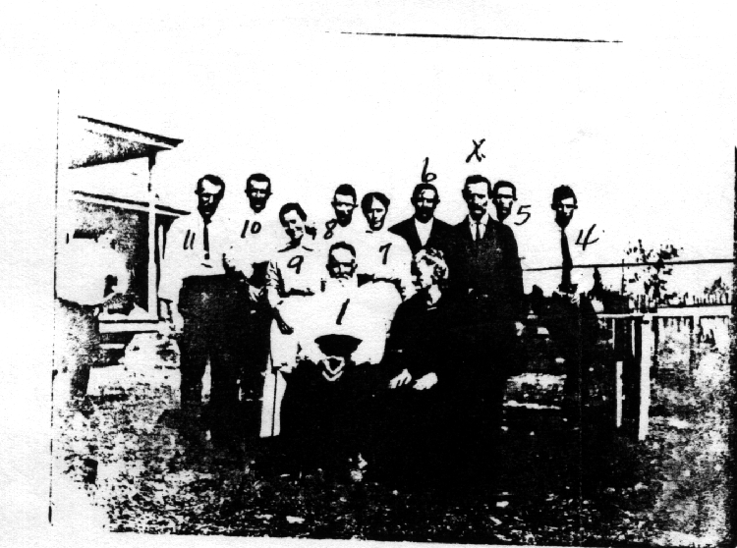

8 May 1911 Age 24 Death of son

His son Andrew Lavern passed away on May 8, 1911, in Cardwell, Missouri, when he was less than a year old. Andrew Lavern SUMMITT 1910–1911 8 May 1911 • Cardwell, Dunklin County, Missouri, United States

12 Feb 1912 Age 24 Birth of son

His son Herbert Allison was born on February 12, 1912, in Cardwell, Missouri. Herbert Allison SUMMITT 1912–1974 12 Feb 1912 • Cardwell, Dunklin, Missouri, United States

21 May 1914 Age 27 Birth of son

His son Raymond Eugene was born on May 21, 1914, in Cardwell, Missouri. Raymond Eugene SUMMITT 1914–1914 21 May 1914 • Cardwell, Dunklin County, Missouri

7 Nov 1914 Age 27 Death of son

His son Raymond Eugene passed away on November 7, 1914, in Cardwell, Missouri, when he was less than a year old. Raymond Eugene SUMMITT 1914–1914 7 Nov 1914 • Cardwell, Dunklin County, Missouri

1914 Age 27

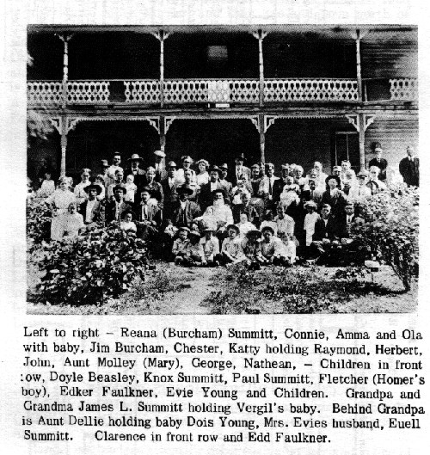

Family Portrait

1914

9 Sep 1915 Age 28 Birth of daughter

His daughter Hettie Augusta was born on September 9, 1915, in Cardwell, Missouri. Hettie Augusta SUMMITT 1915–1916 9 Sep 1915 • Cardwell, Dunklin County, Missouri

17 May1916 Age 29 Death of daughter

His daughter Hettie Augusta passed away on May 17, 1916, in Cardwell, Missouri, when she was less than a year old. Hettie Augusta SUMMITT 1915–1916 17 May 1916 • Cardwell, Dunklin County, Missouri

22 Feb1920 Age 32 Death of half-brother

His half-brother John Franklin died on February 22, 1920, in Henderson, Tennessee, when Chester Alba was 32 years old. John Franklin SUMMITT 1870–1920 22 Feb 1920 • Henderson, Tennessee, United States

31 Mar1920 Age 33 Birth of daughter

His daughter Glendola Dell was born on March 31, 1920, in Cardwell, Missouri. Glendola Dell SUMMITT 1920–2014 31Mar1920 • Cardwell, Dunklin County, Missouri

24 Oct 1920 Age 33 Death of half-brother

His half-brother Nathan Hargus died on October 24, 1920, in Cardwell, Missouri, when Chester Alba was 33 years old. Nathan Hargus SUMMITT 1868–1920 24 Oct 1920 • Cardwell, Dunklin, Missouri, United States

1920 Age 33 Residence

Chester Alba SUMMITT lived in Cardwell, Missouri, in 1920.

**Tell me something about living in Cardwell, Missouri, USA at this time.**

Introduction:

In 1920, Cardwell, Missouri, USA was a small town with a population of around 500 people. Life in Cardwell during this time period was influenced by various factors, including the aftermath of World War I, the Prohibition era, and the evolving role of women in society. Let's explore some unique aspects of living in Cardwell, Missouri, in 1920.

1. Post-War Adjustments:

After World War I, Cardwell, like many other towns in the United States, experienced a period of adjustment. The war had brought significant changes to the economy, and the town had to adapt to the post-war realities. Many returning soldiers faced challenges in finding employment, and the community rallied to support them through various initiatives.

1. Prohibition and Moonshine:

The Prohibition era, which began in 1920, had a notable impact on Cardwell. With the ban on the production, sale, and distribution of alcoholic beverages, the town saw an increase in the production of illegal moonshine. Moonshiners operated discreetly, often in rural areas surrounding Cardwell, to avoid detection by law enforcement. This illicit activity created a unique dynamic within the community.

1. Changing Roles for Women:

In the early 20th century, women's roles in society were evolving, and this was no different in Cardwell. While traditional gender roles still prevailed, some women began to challenge societal norms. They participated in social and civic organizations, advocated for women's suffrage, and sought employment outside the home. These changes brought new opportunities and challenges for women in Cardwell, shaping the fabric of the community.

In conclusion, living in Cardwell, Missouri, in 1920 was marked by post-war adjustments, the influence of Prohibition, and changing roles for women. These unique aspects of life in Cardwell during this time period reflect the broader societal changes occurring across the United States.

1920 • Cardwell, Dunklin, Missouri

**Tell me something about living in Cardwell, Missouri, USA at this time.**

Introduction:

In 1920, Cardwell, Missouri, USA was a small town with a population of around 500 people. Life in Cardwell during this time period was influenced by various factors, including the aftermath of World War I, the Prohibition era, and the evolving role of women in society. Let's explore some unique aspects of living in Cardwell, Missouri, in 1920.

1. Post-War Adjustments:

After World War I, Cardwell, like many other towns in the United States, experienced a period of adjustment. The war had brought significant changes to the economy, and the town had to adapt to the post-war realities. Many returning soldiers faced challenges in finding employment, and the community rallied to support them through various initiatives.

1. Prohibition and Moonshine:

The Prohibition era, which began in 1920, had a notable impact on Cardwell. With the ban on the production, sale, and distribution of alcoholic beverages, the town saw an increase in the production of illegal moonshine. Moonshiners operated discreetly, often in rural areas surrounding Cardwell, to avoid detection by law enforcement. This illicit activity created a unique dynamic within the community.

1. Changing Roles for Women:

In the early 20th century, women's roles in society were evolving, and this was no different in Cardwell. While traditional gender roles still prevailed, some women began to challenge societal norms. They participated in social and civic organizations, advocated for women's suffrage, and sought employment outside the home. These changes brought new opportunities and challenges for women in Cardwell, shaping the fabric of the community.

In conclusion, living in Cardwell, Missouri, in 1920 was marked by post-war adjustments, the influence of Prohibition, and changing roles for women. These unique aspects of life in Cardwell during this time period reflect the broader societal changes occurring across the United States.

29 Jun 1922 Age 35 Death of mother

His mother Lucy Frances passed away on June 29, 1922, in Dyersburg, Tennessee, at the age of 67. Lucy Frances WHITE 1855–1922 29 Jun 1922 • Dyersburg, Dyer, Tennessee, United States

26 Jun 1924 Age 37 Death of sister

His sister Cordelia Elisabeth (Delia) died on June 26, 1924, in Dyer, Tennessee, when Chester Alba was 37 years old. Cordelia Elisabeth (Delia) SUMMITT 1885–1924 26Jun1924 • Dyer, Tennessee, United States As can be seen on the death certificate below, Cordelia was struck by ball lightning while hanging out the laundry on a clear day.

1 Jul 1924 Age 37 Birth of daughter

His daughter "Lady" Ruth was born on July 1, 1924, in Cardwell, Missouri. "Lady" Ruth SUMMITT 1924–2018 1 Jul 1924 • Cardwell (Dunklin) Missouri USA I have her listed as “Lady” Ruth because that was what my dad always called her. Her children inform me that her name was simply Ruth.

13 Jan 1927 Age 39 Death of father

His father James Lee passed away on January 13, 1927, in Cardwell, Missouri, at the age of 86. James Lee SUMMITT 1840–1927 13 Jan 1927 • Cardwell, Dunklin, Missouri, United States

23 Oct1927 Age 40 Birth of son

His son William Sherrill was born on October 23, 1927, in Cardwell, Missouri. William Sherrill SUMMITT 1927–1989 23 Oct 1927 • Cardwell, Dunklin, Missouri, United States

31 Mar 1928 Age 41 Death of half-brother

His half-brother Robert Francis died on March 31, 1928, in Monroe, Arkansas, when Chester Alba was 41 years old. Robert Francis SUMMITT 1874–1928 31 Mar 1928 • Monroe, Monroe, Arkansas, United States

1930 Age 43 Residence Chester Alba SUMMITT lived in Buffalo, Missouri, in 1930. 1930 • Buffalo, Dunklin, Missouri

**Tell me something about living in Missouri, USA at this time.**

Introduction:

Living in Missouri, USA in 1930 offered a unique experience shaped by the historical context and cultural diversity of the time. From the bustling cities to the rural landscapes, Missouri provided a range of opportunities and challenges for its residents.

1. Economic Challenges:

During the Great Depression, Missouri faced economic hardships like the rest of the country. Many Missourians struggled with unemployment and poverty. However, the state's agricultural sector provided some stability, as farming remained a crucial part of the economy. Farmers grew crops such as corn, wheat, and soybeans, while also raising livestock like cattle and hogs.

1. Cultural Diversity:

Missouri was home to a diverse population, including Native American tribes such as the Osage, Delaware, and Shawnee. African Americans, both free and enslaved, played a significant role in the state's history. The cities of St. Louis and Kansas City were vibrant cultural hubs, with thriving music scenes and a rich African American heritage. Jazz and blues music flourished, with renowned musicians like Scott Joplin and Charlie Parker emerging from Missouri.

1. Natural Beauty and Outdoor Recreation:

Missouri's natural landscapes offered opportunities for outdoor recreation. The state boasted beautiful rivers like the Mississippi and Missouri, which provided fishing and boating activities. The Ozark Mountains in southern Missouri offered scenic beauty and opportunities for hiking and camping. Additionally, the state's numerous parks and conservation areas allowed residents to enjoy nature and engage in outdoor activities.

In conclusion, living in Missouri, USA in 1930 presented both challenges and unique experiences. The economic difficulties of the Great Depression affected many residents, but the state's cultural diversity and natural beauty offered opportunities for growth, creativity, and outdoor recreation.

**Tell me something about living in Missouri, USA at this time.**

Introduction:

Living in Missouri, USA in 1930 offered a unique experience shaped by the historical context and cultural diversity of the time. From the bustling cities to the rural landscapes, Missouri provided a range of opportunities and challenges for its residents.

1. Economic Challenges:

During the Great Depression, Missouri faced economic hardships like the rest of the country. Many Missourians struggled with unemployment and poverty. However, the state's agricultural sector provided some stability, as farming remained a crucial part of the economy. Farmers grew crops such as corn, wheat, and soybeans, while also raising livestock like cattle and hogs.

1. Cultural Diversity:

Missouri was home to a diverse population, including Native American tribes such as the Osage, Delaware, and Shawnee. African Americans, both free and enslaved, played a significant role in the state's history. The cities of St. Louis and Kansas City were vibrant cultural hubs, with thriving music scenes and a rich African American heritage. Jazz and blues music flourished, with renowned musicians like Scott Joplin and Charlie Parker emerging from Missouri.

1. Natural Beauty and Outdoor Recreation:

Missouri's natural landscapes offered opportunities for outdoor recreation. The state boasted beautiful rivers like the Mississippi and Missouri, which provided fishing and boating activities. The Ozark Mountains in southern Missouri offered scenic beauty and opportunities for hiking and camping. Additionally, the state's numerous parks and conservation areas allowed residents to enjoy nature and engage in outdoor activities.

In conclusion, living in Missouri, USA in 1930 presented both challenges and unique experiences. The economic difficulties of the Great Depression affected many residents, but the state's cultural diversity and natural beauty offered opportunities for growth, creativity, and outdoor recreation.

9 Sep 1931 Age 44 Birth of son

His son Chester Moody was born on September 9, 1931, in Cardwell, Missouri. Chester Moody SUMMITT 1931–2009 09 Sep 1931 • Cardwell, Dunklin, Missouri

23 Aug1934 Age 47 Birth of daughter

His daughter Alice Lucretia was born on August 23, 1934, in Cardwell, Missouri. Alice Lucretia SUMMITT 1934–1935 23 Aug 1934 • Cardwell, Dunklin County, Missouri, USA

9 Feb1935 Age 47 Death of daughter

His daughter Alice Lucretia passed away on February 9, 1935, in Cardwell, Missouri, when she was less than a year old. Alice Lucretia SUMMITT 1934–1935 9 Feb 1935 • Cardwell, Dunklin County, Missouri, USA

1939 Age 52 Death of half-brother

His half-brother William Allen died in 1939 in Dyer, Tennessee, when Chester Alba was 52 years old. William Allen YOUNG 1873–1939 1939 • Dyer, Tennessee, United States

1 Apr 1940 Age 53 Residence

Chester Alba SUMMITT lived in Cardwell, Missouri, on April 1, 1940. 1 Apr 1940 • Cardwell, Dunklin, Missouri, United States

**Tell me something about living in Cardwell, Missouri, USA at this time.**

Introduction:

Cardwell, Missouri, USA in 1940 was a small town with a population of approximately 800 people. Nestled in the southeastern part of the state, Cardwell offered a unique experience for its residents during that time period. Let's explore some of the distinctive aspects of living in Cardwell in 1940.

1. Agricultural Community:

Cardwell was primarily an agricultural community, with farming being the main occupation for many residents. The fertile soil and favorable climate allowed for the cultivation of crops such as cotton, corn, and soybeans. Farming played a crucial role in the local economy, shaping the daily lives and routines of the townspeople.

1. Close-knit Community:

Living in Cardwell in 1940 meant being part of a close-knit community. Neighbors knew each other well and often came together for social gatherings, church events, and community celebrations. The town's small size fostered a strong sense of camaraderie and support among its residents, creating a tight-knit community where everyone looked out for one another.

1. Limited Modern Amenities:

In 1940, Cardwell had limited modern amenities compared to larger cities. Electricity was available, but indoor plumbing was not yet widespread. Many households relied on wells for water and outhouses for sanitation. Despite these challenges, the resourcefulness and resilience of the townspeople allowed them to adapt and make the most of what they had.

Conclusion:

Living in Cardwell, Missouri, USA in 1940 offered a unique experience characterized by its agricultural roots, close-knit community, and limited modern amenities. The town's reliance on farming, strong community bonds, and resourcefulness shaped the daily lives of its residents, creating a distinct way of life that was both challenging and rewarding.

**Tell me something about living in Cardwell, Missouri, USA at this time.**

Introduction:

Cardwell, Missouri, USA in 1940 was a small town with a population of approximately 800 people. Nestled in the southeastern part of the state, Cardwell offered a unique experience for its residents during that time period. Let's explore some of the distinctive aspects of living in Cardwell in 1940.

1. Agricultural Community:

Cardwell was primarily an agricultural community, with farming being the main occupation for many residents. The fertile soil and favorable climate allowed for the cultivation of crops such as cotton, corn, and soybeans. Farming played a crucial role in the local economy, shaping the daily lives and routines of the townspeople.

1. Close-knit Community:

Living in Cardwell in 1940 meant being part of a close-knit community. Neighbors knew each other well and often came together for social gatherings, church events, and community celebrations. The town's small size fostered a strong sense of camaraderie and support among its residents, creating a tight-knit community where everyone looked out for one another.

1. Limited Modern Amenities:

In 1940, Cardwell had limited modern amenities compared to larger cities. Electricity was available, but indoor plumbing was not yet widespread. Many households relied on wells for water and outhouses for sanitation. Despite these challenges, the resourcefulness and resilience of the townspeople allowed them to adapt and make the most of what they had.

Conclusion:

Living in Cardwell, Missouri, USA in 1940 offered a unique experience characterized by its agricultural roots, close-knit community, and limited modern amenities. The town's reliance on farming, strong community bonds, and resourcefulness shaped the daily lives of its residents, creating a distinct way of life that was both challenging and rewarding.

1940 Age 53 Residence

Chester Alba SUMMITT lived in Cardwell, Missouri, in 1940.

Chester A Summitt - 1940 Census

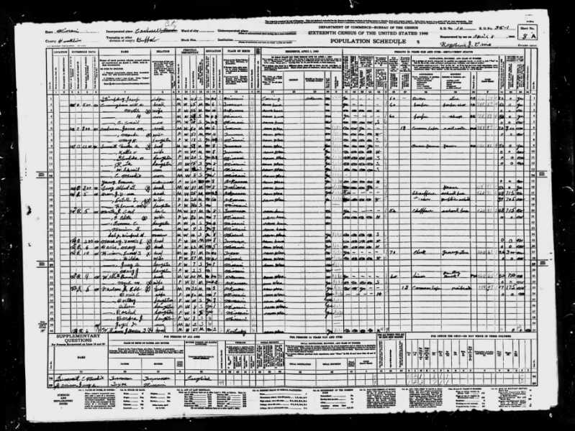

1940 • Cardwell, Dunklin, Missouri, United States

1942 Age 55 Military

Chester Alba SUMMITT registered for the draft again in 1942 in Cardwell, Missouri, when he was 55 years old.

WWII Draft Registration

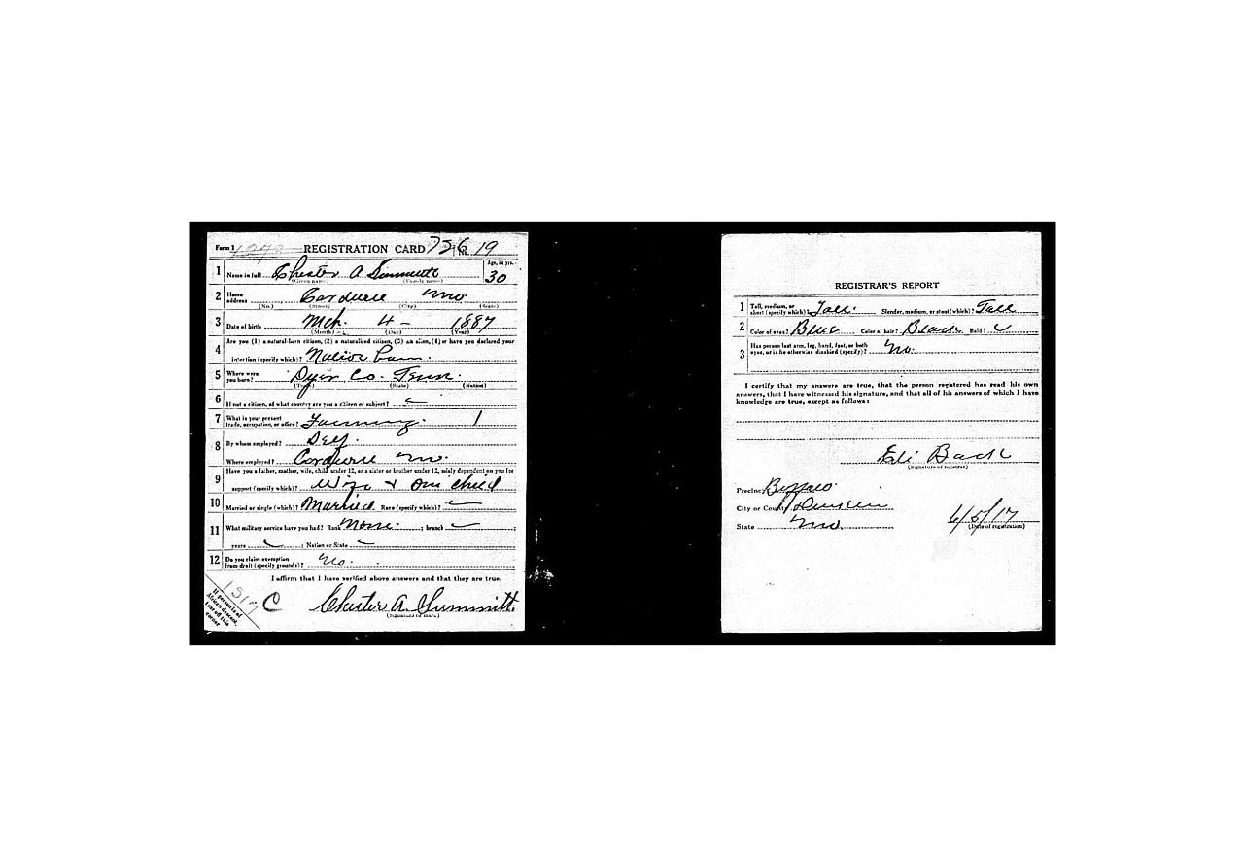

1942 • Cardwell (Dunklin) Missouri USA

**What was enlistment like at this time?**

Introduction:

In 1942, military enlistment in Cardwell, Missouri, USA was influenced by the ongoing events of World War II. Young men from Cardwell and its surrounding areas felt a strong sense of duty and patriotism, leading many to join the armed forces. This period marked a significant shift in the demographics and dynamics of the community.

1. Enlistment Process:

To enlist, individuals in Cardwell had to meet certain criteria, including age, physical fitness, and citizenship. They would typically visit the local recruitment office, where they would undergo medical examinations and fill out paperwork. Once accepted, they would be sent to training camps across the country for basic military training.

1. Impact on the Community:

The enlistment of young men in Cardwell had a profound impact on the community. Families bid farewell to their loved ones, uncertain of when or if they would return. The absence of these individuals affected the local economy, as businesses adjusted to the loss of workers. However, the community rallied together, organizing support groups and events to boost morale and provide assistance to those serving overseas.

1. Diversity in Enlistment:

The enlistment in Cardwell was not limited to a specific ethnic or cultural group. Men from various backgrounds, including different ethnicities, religions, and socioeconomic classes, answered the call to serve. This diversity fostered a sense of unity and camaraderie among the enlisted individuals, as they worked together towards a common goal of defending their country.

In conclusion, military enlistment in Cardwell, Missouri, USA in 1942 was a significant event shaped by the circumstances of World War II. Young men from diverse backgrounds joined the armed forces, leaving their families and impacting the local community. Their enlistment was a testament to their patriotism and dedication to defending their country during a challenging time.

1950 Age 63 Residence Chester Alba SUMMITT lived in Cardwell, Missouri, in 1950. 1950 • Cardwell, Dunklin, Missouri, USA

Cardwell, Missouri, in 1950 was a small, rural town in the southeastern part of the state. At that time, it was a typical American small town, with a close-knit community and a slower pace of life compared to urban areas.

**Economic and Social Life:**

* **Agriculture**: The local economy was largely based on agriculture, with many residents involved in farming and related activities. The landscape was characterized by fields and farms.
* **Community**: Social life revolved around community events, church gatherings, and local schools. People often knew their neighbors well, and social activities were centered around local institutions like churches and schools.
* **Business**: The town likely had a few small businesses such as general stores, diners, and local services catering to the needs of the community.

**Infrastructure:**

* **Transportation**: Transportation options were limited compared to today. Many people relied on cars for travel, but roads might not have been as developed as they are now.
* **Amenities**: Amenities were modest. While there would have been essential services, more specialized or luxury services might have required travel to a nearby larger town or city.

**Culture and Society:**

* **Daily Life**: Daily life in Cardwell would have been influenced by traditional values and practices of the time. Family life was central, and many people engaged in outdoor and community-based activities.
* **Media and Entertainment**: Entertainment options were limited compared to today, with radio and early television being primary sources of news and entertainment. Community events, radio shows, and local gatherings played significant roles in social life.

Overall, Cardwell in 1950 was reflective of many small towns in the U.S. during that era, with a strong sense of community, a reliance on agriculture, and a slower, more localized way of life.

27 Oct 1951 Age 64 Death of half-sister

His half-sister Beaulah Alberta died on October 27, 1951, in Fowlkes, Tennessee, when Chester Alba was 64 years old. Beaulah Alberta YOUNG 1879–1951 27 Oct 1951 • Fowlkes, Dyer, Tennessee, USA

Abt 1952 Age 65

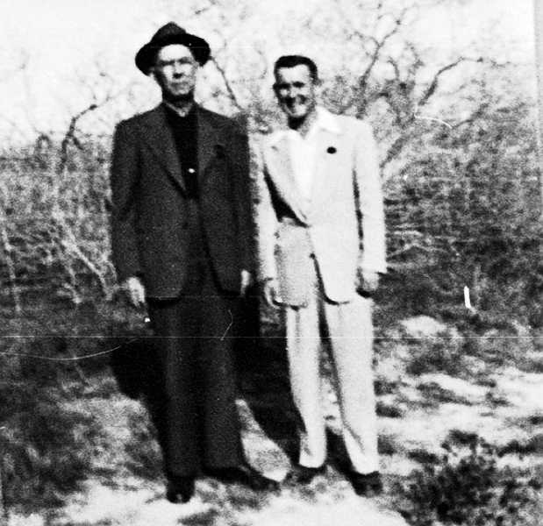Chester Alba Summitt and Chester Moody Summitt

21 Oct 1953 Age 66 Death of wife

His wife Katie Okalona passed away on October 21, 1953, in Memphis, Tennessee, at the age of 63. They had been married 45 years. Katie Okalona DARDEN 1890–1953 21 Oct 1953 • Memphis, Shelby, Tennessee, United States

Abt 1953 Age 66

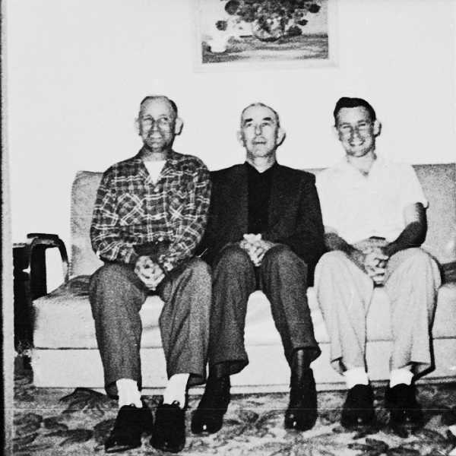

Herbert, Papa, & Dad

(left to right) Herbert Allison Summitt, Chester Alba Summitt, and Chester Moody Summitt

Abt 1953 Age 66

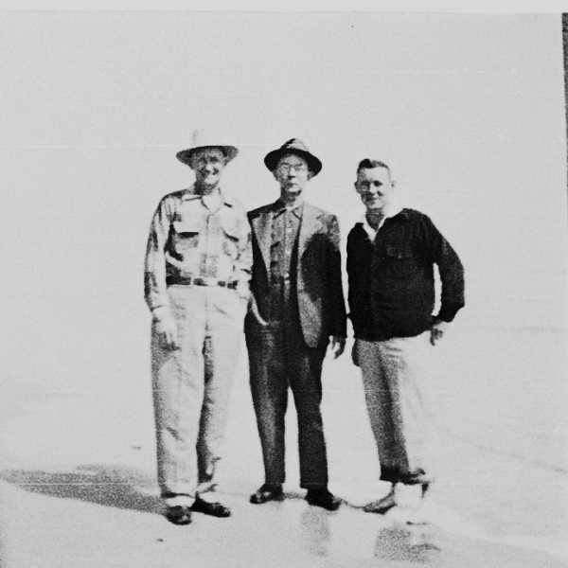Herbert, Papa, & Dad

(left to right) Herbert Allison Summitt, Chester Alba Summitt, and Chester Moody Summitt

Apr 1954 Age 67

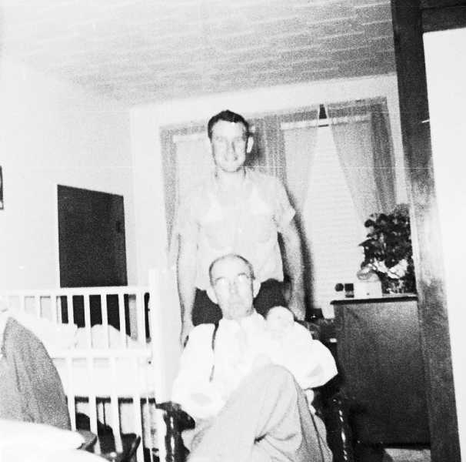Paul Moody Summitt, Chester Alba Summitt, and Chester Moody Summitt

abt April 1954 Age 67

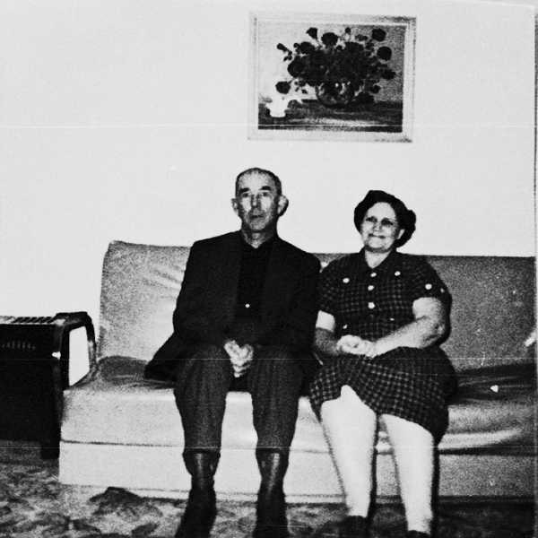Papa and Dessie Blackburn

Chester Alba Summitt and Dessie Blackburn

5 Apr 1955 Age 68 Marriage

Chester Alba SUMMITT married Lily Mae WILLIS in Cardwell, Missouri, on April 5, 1955, when he was 68 years old. Lily Mae WILLIS 1898– 5 Apr 1955 • Cardwell, Dunklin, Missouri, United States

1955 Age 68

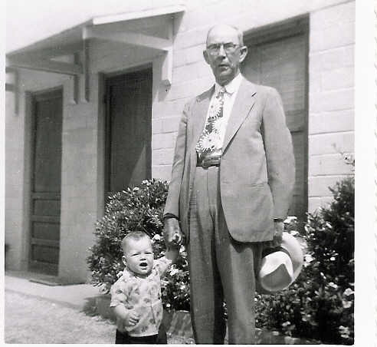

Chester Alba Summitt & Paul Moody Summitt 1955

Aft 1955 Age 68 Marriage

Chester Alba SUMMITT married Carrie R BUCK in 1955 when he was 68 years old. Carrie R BUCK 1905–1994 aft 1955

3 Jul 1956 Age 69 Death of brother

His brother George Weekly died on July 3, 1956, in Memphis, Tennessee, when Chester Alba was 69 years old. George Weekly SUMMITT 1891–1956 3 Jul 1956 • Memphis, Shelby, Tennessee

1967 Age 80

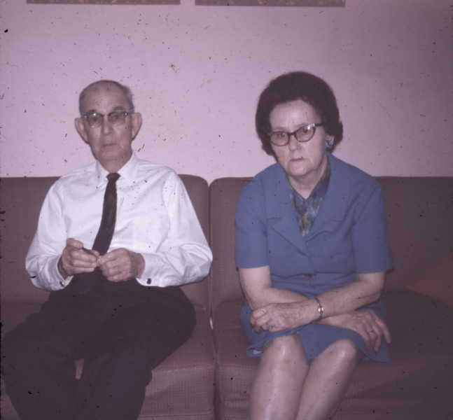Chester & Miss Carrie

20 Jun1969 Age 82 Death of brother

His brother Joseph Homer died on June 20, 1969, in Jackson, Tennessee, when Chester Alba was 82 years old. Joseph Homer SUMMITT 1889–1969 20 Jun 1969 • Jackson, Madison, Tennessee, United States

10 Mar 1970 Age 83 Death

Chester Alba SUMMITT died on March 10, 1970, in Memphis, Tennessee, when he was 83 years old. Age at Death: 83 10 Mar 1970 • Memphis, Shelby County, Tennessee

Memphis, Tennessee, in 1970 was a vibrant and evolving city with a rich cultural and historical landscape. It was a time of significant change and growth, reflecting broader social and economic trends of the period.

**Economic and Social Life:**

* **Economic Hub**: Memphis was a key economic center in the region, known for its strong ties to the transportation industry, particularly with its major railroads and proximity to the Mississippi River. The city was also becoming recognized for its contributions to the music and entertainment industries.
* **Music and Culture**: The city was a crucial hub for music, especially blues, soul, and rock 'n' roll. By 1970, Memphis had established itself as the home of legendary artists like Elvis Presley, B.B. King, and Isaac Hayes. Stax Records and Sun Studio were iconic landmarks, contributing to Memphis's reputation as the "Home of the Blues" and the "Birthplace of Rock 'n' Roll."
* **Civil Rights Movement**: The city was deeply affected by the Civil Rights Movement. In 1968, Dr. Martin Luther King Jr. was assassinated at the Lorraine Motel in Memphis. This event marked a significant moment in the city’s history and had a lasting impact on its social and cultural landscape. In 1970, the city was continuing to deal with the aftermath and working through ongoing issues related to race relations and civil rights.

**Demographics and Community:**

* **Population Growth**: Memphis was experiencing growth and urbanization. The population was diverse, with a significant African American community playing a central role in the city's culture and economy.
* **Neighborhoods**: Various neighborhoods reflected the city’s diversity, from historic areas like Beale Street, known for its musical heritage, to more residential and industrial zones.

**Infrastructure and Daily Life:**

* **Transportation**: Memphis was well-connected by major highways and railroads. The city was a transportation hub with its strategic location along the Mississippi River and its role as a key stop for railroads.
* **Amenities and Services**: In 1970, Memphis had a range of services and amenities, including schools, healthcare facilities, and recreational options. However, like many American cities at the time, it was also facing challenges related to urban development and infrastructure.
* **Entertainment and Leisure**: Besides its musical legacy, Memphis offered various cultural and recreational activities. The city’s parks, museums, and theaters were important parts of community life.

Overall, Memphis in 1970 was a city marked by cultural richness and historical significance, experiencing both the challenges and opportunities of a rapidly changing era.

11 Mar 1970 Age 83

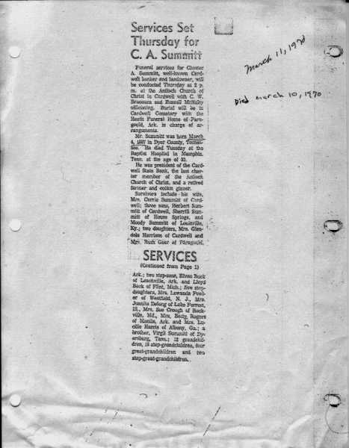

Obituary of Chester Alba Summitt

March 11, 1970 Burial Cardwell, Dunklin County, Missouri, USA

Residence Chester Alba SUMMITT lived in Dunklin County, Missouri.